**TM4112**

**RESERVOIR CHARACTERIZATION AND MODELLING**

**FINAL REPORT**

Name : Marcellinus Chrisnada Putra 12213004

Lecturer : Dr.Eng. Ir. Sutopo, M.Eng.

Assistant : Wira Dharma Kencana Putra 12213048

Kevin Tja 12213058

Submission Date : 19 December 2017



FAKULAS TEKNIK PERTAMBANGAN DAN PERMINYAKAN

PROGRAM STUDI TEKNIK PERMINYAKAN

INSTITUT TEKNOLOGI BANDUNG

2017

# Contents

2 Continuity Equation 3

3 Fluid Mode 3

4 Continuity Equation for Multiphase Flow 3

5 Momentum Balance 4

6 Flow Equation in Porous Media 5

7 Discretization of Diffusivity Equation 5

7.1 Central difference in space 5

7.2 Backward in time 6

8 Discretized Diffusivity Equation 6

9 Residual Function 7

10 Residual Function 7

11 Partial Differential Equation of Residual Function to Pressure 8

11.1 Flux Term (LHS) 8

11.2 Sink-Source & Accumulation Term (RHS) 8

12 Partial Differential Equation of Residual Function to Water Saturation 9

12.1 Flux Term (LHS) 9

12.2 Sink-Source & Accumulation Term (RHS) 9

12.3 Jacobian Matrix for Residual Function 9

12.4 Painful Truth 9

12.5 Notation Simplification 10

12.6 Residual Function in Newton-Raphson Algorithm 11

13 Flow Chart 13

14 Waterflood Sensitivity Study 14

14.1 Method of Sensitivity Study 14

14.2 Validation Using Commercial Simulator 14

14.3 Recovery Factor Optimization 19

14.3.1 Injection Rate Sensitivity 19

14.3.2 Completion Location Sensitivity 20

14.3.3 Recommended Scenario 21

15 Additional Notes 22

15.1 Upstream Weighting 22

15.2 Fluid Physical Properties at Average Pressure 22

15.3 Partial Derivatives of Transmissibility to Neighbor Pressure and Water Saturation 23

15.4 Bivariate Newton-Raphson 23

15.5 Easy Way to Calculate Flux Term Derivate at Block 23

# Figures

Figure 1. Flagging Visualization on Grid Model (Neighbor and Itself) 11

Figure 2. 5x5x5 Grid Model Used in Simulation 12

Figure 3. 5x5x5 Grid Model’s Coefficient Matrix Sample 1 12

Figure 4. 5x5x5 Grid Model's Coefficient Matrix Sample 2 13

Figure 5. Fortran 90 Reservoir Simulator Flow Chart 13

Figure 6. Reservoir Geometry and Well Location 14

Figure 7. Result Comparison on Injection Rate vs Time 14

Figure 8. Result Comparison on Oil Production Rate vs Time 15

Figure 9. Result Comparison on Water Production Rate vs Time 15

Figure 10. Result Comparison on Water Cut vs Time 16

Figure 11. Result Comparison on Water-Oil Ratio vs Time 16

Figure 12. Result Comparison on Cummulative Water Injected vs Time 17

Figure 13. Result Comparison on Cummulative Oil Produced vs Time 17

Figure 14. Result Comparison on Cummulative Water Produced vs Time 18

Figure 15. Result Comparison on Injector Wellbore Pressure vs Time 18

Figure 16. Result Comparison on Producer Wellbore Pressure vs Time 19

Figure 17. Recovery Factor Sensitivity to Injection Rate 20

Figure 18. Recovery Factor Sensitivity to Well Perforation Depth 21

# Tables

Table 1. Cases for Different Injection Rate 19

Table 2. Cases for Different Well Perforation Depth 20

Table 3. Recommended Case on Recovery Factor Optimization 22

# Continuity Equation

Recall mass balance

$${\dot{m}}_{in}-{\dot{m}}_{out}={\dot{m}}_{accumulation}+{\dot{m}}_{sink}-{\dot{m}}_{source}$$

For 3-D flow

$${\dot{m}}_{in}={\left(ρQ\right)}_{x}+{\left(ρQ\right)}_{y}+{\left(ρQ\right)}_{z}={\left(ρAv\right)}_{x}+{\left(ρAv\right)}_{y}+{\left(ρAv\right)}_{z}$$

$${\dot{m}}_{out}={\left(ρQ\right)}_{x+∆x}+{\left(ρQ\right)}_{y+∆y}+{\left(ρQ\right)}_{z+∆z}={\left(ρAv\right)}_{x+∆x}+{\left(ρAv\right)}_{y+∆y}+{\left(ρAv\right)}_{z+∆z}$$

Thus, for one-phase flow and assumed there is no source term because only production process occurs in this flow model

$$-V_{b}\left[\frac{∆\left(ρv_{x}\right)}{∆x}+\frac{∆\left(ρv_{y}\right)}{∆y}+\frac{∆\left(ρv_{z}\right)}{∆z}\right]={\dot{m}}_{sink}+V_{b}\frac{∆(ρϕS)}{∆t}$$

$$-V_{b}\left[\frac{∂\left(ρv_{x}\right)}{∂x}+\frac{∂\left(ρv_{y}\right)}{∂y}+\frac{∂\left(ρv_{z}\right)}{∂z}\right]={\dot{m}}_{sink}+V_{b}\frac{∂(ρϕS)}{∂t}$$

$$-V_{b}∇∙(ρ\vec{v})={{\dot{m}}_{sink}+V}_{b}\frac{∂(ρϕS)}{∂t}$$

With

$$∇∙(ρ\vec{v})=\left(\begin{matrix}∂/∂x \\ ∂/∂y \\ ∂/∂z\end{matrix}\right) ∙\left(\begin{matrix}ρv_{x} \\ ρv_{y} \\ ρv_{z}\end{matrix}\right)$$

$${\dot{m}}_{sink}=ρQ_{prod}$$

# Fluid Mode

Fluid densities for oil, gas and water respectively

$$ρ_{o}=\frac{ρ_{o}^{s}+R_{s}ρ_{g}^{s}}{B_{o}}$$

$$ρ_{g}=\frac{ρ_{g}^{s}}{B_{g}}$$

$$ρ_{w}=\frac{ρ_{w}^{s}}{B_{w}}$$

# Continuity Equation for Multiphase Flow

Plug in fluid model for oil, gas, and water respectively to mass balance equation

$$-V_{b}∇∙\left(\frac{ρ_{o}^{s}}{B_{o}}{\vec{v}}_{o}\right)=ρ_{o}^{s}{q_{o}+V}_{b}\frac{∂}{∂t}\left(\frac{ρ_{o}^{s}}{B_{o}}ϕS_{o}\right)$$

$$-V_{b}∇∙\left(\frac{ρ_{g}^{s}}{B_{g}}{\vec{v}}_{g}\right)+R_{s}\left[-V_{b}∇∙\left(\frac{ρ_{g}^{s}}{B_{g}}{\vec{v}}_{o}\right)\right]=ρ_{g}^{s}{q_{g}+R_{s}\left(ρ_{o}^{s}q_{o}\right)+V}_{b}\frac{∂}{∂t}\left(\frac{ρ_{g}^{s}}{B_{g}}ϕS_{g}\right)+R_{s}\left\{V_{b}\frac{∂}{∂t}\left(\frac{ρ_{o}^{s}}{B_{o}}ϕS_{o}\right) \right\}$$

$$-V_{b}∇∙\left(\frac{ρ_{w}^{s}}{B_{w}}{\vec{v}}_{w}\right)=ρ_{w}^{s}{q_{w}+V}_{b}\frac{∂}{∂t}\left(\frac{ρ_{w}^{s}}{B_{w}}ϕS_{w}\right)$$

For So + Sw = 1 (oil-water system), and Rs = 0 (dead oil)

$$-V_{b}∇∙\left(\frac{ρ_{o}^{s}}{B_{o}}{\vec{v}}_{o}\right)=ρ_{o}^{s}{q_{o}+V}_{b}\frac{∂}{∂t}\left(\frac{ρ_{o}^{s}}{B_{o}}ϕS_{o}\right)$$

$$-V_{b}∇∙\left(\frac{ρ_{w}^{s}}{B_{w}}{\vec{v}}_{w}\right)=ρ_{w}^{s}{q_{w}+V}_{b}\frac{∂}{∂t}\left(\frac{ρ_{w}^{s}}{B_{w}}ϕS_{w}\right)$$

Since a fluid mobility is expressed as

$$λ=\frac{kk_{r}}{μB}$$

Then, qw and qo can be expressed in qt using fractional flow

$$q_{w}=f_{w}q_{t}$$

$$q_{o}=f_{o}q_{t}=\left(1-f_{w}\right)q_{t}$$

$$f_{w}=\frac{M}{M+1}$$

$$M=\frac{λ_{w}}{λ_{o}}=\frac{μ_{o}B_{o}}{μ_{w}B_{w}}\frac{k_{rw}}{k_{ro}}$$

Thus

$$-V_{b}∇∙\left(\frac{{\vec{v}}_{o}}{B_{o}}\right)={\left(1-f_{w}\right)q_{t}+V}_{b}\frac{∂}{∂t}\left(\frac{ϕ\left(1-S_{w}\right)}{B_{o}}\right)$$

$$-V_{b}∇∙\left(\frac{{\vec{v}}_{w}}{B_{w}}\right)={f_{w}q_{t}+V}_{b}\frac{∂}{∂t}\left[\frac{ϕS_{w}}{B_{w}}\right]$$

# Momentum Balance

Recall Darcy’s equation for one-dimensional flow

$$\vec{v}=-\frac{k k{}_{r}}{μ}\left(∇p-γ∇z\right)$$

Substitution with mobility

$$-\frac{\vec{v}}{B}=λ\left(∇p-γ∇z\right)$$

Recall L.H.S of continuity equation then it can be expressed in Darcy’s equation

Note that there is no gravitational effect in horizontal flow (x and y axis)

$$-∇∙\left(\frac{\vec{v}}{B}\right)=∇∙\left[λ\left(∇p-γ∇z\right)\right]=\left(\begin{matrix}\frac{∂}{∂x} & \frac{∂}{∂y} & \frac{∂}{∂z}\end{matrix}\right)∙\left[\begin{matrix}λ_{x}p_{x} \\ λ_{y}p_{y} \\ λ_{z}(p_{z}-γ∇z)\end{matrix}\right]$$

$$-∇∙\left(\frac{\vec{v}}{B}\right)=\frac{∂}{∂x}\left(λ_{x}\frac{∂p}{∂x}\right)+\frac{∂}{∂y}\left(λ_{y}\frac{∂p}{∂y}\right)+\frac{∂}{∂z}\left(λ_{z}\frac{∂p}{∂z}\right)-\frac{∂}{∂z}\left(λ_{z}γ∇z\right)$$

# Flow Equation in Porous Media

Substituting momentum balance to L.H.S of continuity equation for oil and water respectively

$$V_{b}\left[\frac{∂}{∂x}\left(λ_{ox}\frac{∂p}{∂x}\right)+\frac{∂}{∂y}\left(λ_{oy}\frac{∂p}{∂y}\right)+\frac{∂}{∂z}\left(λ_{oz}\frac{∂p}{∂z}\right)-\frac{∂}{∂z}\left(λ_{oz}γ∇z\right)\right]={\left(1-f_{w}\right)q_{t}+V}_{b}\frac{∂}{∂t}\left(\frac{ϕ\left(1-S_{w}\right)}{B_{o}}\right)$$

$$V_{b}\left[\frac{∂}{∂x}\left(λ_{wx}\frac{∂p}{∂x}\right)+\frac{∂}{∂y}\left(λ_{wy}\frac{∂p}{∂y}\right)+\frac{∂}{∂z}\left(λ_{wz}\frac{∂p}{∂z}\right)-\frac{∂}{∂z}\left(λ_{wz}γ∇z\right)\right]={f_{w}q_{t}+V}_{b}\frac{∂}{∂t}\left[\frac{ϕS_{w}}{B_{w}}\right]$$

# Discretization of Diffusivity Equation

## Central difference in space

$$\frac{∂^{2}p}{∂x^{2}}=\frac{p_{i-1}-2p{}_{i}+p_{i+1}}{{\left(∆x\right)}^{2}}$$

Twice derivation with a length of stencil equals a half grid is needed to achieve a second order of pressure differential to space with a length of stencil equals 1 grid

$$\frac{∂p}{∂x}=\frac{p_{i+\frac{1}{2}}-p_{i-\frac{1}{2}}}{∆x}$$

For x-direction

$$\frac{∂}{∂x}\left(λ_{x }\frac{∂p}{∂x} \right)=\frac{{\left(λ_{x}\frac{∂p}{∂x}\right)}_{i+\frac{1}{2}}-{\left(λ_{x}\frac{∂p}{∂x}\right)}_{i-\frac{1}{2}}}{∆x}$$

$$\frac{∂}{∂x}\left(λ_{x }\frac{∂p}{∂x} \right)=\frac{{\left(λ_{x}\right)}_{i+\frac{1}{2}}\left(\frac{p_{i+1}-p_{i}}{∆x}\right)-{\left(λ_{x}\right)}_{i-\frac{1}{2}}\left(\frac{p_{i}-p_{i-1}}{∆x}\right)}{∆x}$$

Values of pressure that will be used are still the ones in the middle of grid blocks

Meanwhile, mobility will use values in the boundary between grid blocks

Thus, for differential change of mobility in a particular bulk volume can be expressed as

$$V_{b}\frac{∂}{∂x}\left(λ_{x}\frac{∂p}{∂x}\right)≈λ_{i+\frac{1}{2}}∆y∆z\left(\frac{p_{i+1}-p_{i}}{∆x}\right)+λ_{i-\frac{1}{2}}∆y∆z\left(\frac{p_{i-1}-p_{i}}{∆x}\right)$$

Define transmissibility

$$TX_{i+\frac{1}{2}}=\frac{∆y∆z}{∆x}λ_{i+\frac{1}{2}}$$

Substitution

$$V_{b}\frac{∂}{∂x}\left(λ_{x}\frac{∂p}{∂x}\right)≈TX_{i+\frac{1}{2}}\left(p_{i+1}-p_{i}\right)+TX_{i-\frac{1}{2}}\left(p_{i-1}-p_{i}\right)$$

For gravity term

$$\frac{∂}{∂z}\left(λ_{z}γ_{z}∇z\right)=\frac{∂}{∂x}\left(λ_{z}γ_{z}\frac{∂z}{∂z}\right)$$

$$V_{b}\frac{∂}{∂z}\left(λ_{z}γ_{z}∇z\right)≈TX_{k+\frac{1}{2}} γ_{k+\frac{1}{2}} \left(z_{k+1}-z_{k}\right)+TX_{k-\frac{1}{2}} γ_{k-\frac{1}{2}} \left(z_{k-1}-z_{k}\right)$$

$$TX_{k±\frac{1}{2}}=\frac{∆x∆y}{∆z}λ_{k±\frac{1}{2}}$$

Constant grid is assumed therefore, there are no notation given for $∆x$, $∆y$ and $∆z$ since the values are always same

## Backward in time

$$V_{b}\frac{∂}{∂t}{\left(\frac{ϕS}{B}\right)}^{t}=\frac{V_{b}}{∆t}\left[{\left(\frac{ϕS}{B}\right)}^{t+1}-{\left(\frac{ϕS}{B}\right)}^{t}\right]$$

# Discretized Diffusivity Equation

Assumed that Pcow = 0, then Po = Pg = Pw

Recall diffusivity equation for plug in transmissibility for substitution

For oil

$$V_{b}\left[\frac{∂}{∂x}\left(λ_{ox}\frac{∂p}{∂x}\right)+\frac{∂}{∂y}\left(λ_{oy}\frac{∂p}{∂y}\right)+\frac{∂}{∂z}\left(λ_{oz}\frac{∂p}{∂z}\right)-\frac{∂}{∂z}\left(λ_{oz}γ∇z\right)\right]={\left(1-f_{w}\right)q_{t}+V}_{b}\frac{∂}{∂t}\left(\frac{ϕ\left(1-S_{w}\right)}{B_{o}}\right)$$

$${\left[TX_{o_{i+\frac{1}{2}}}\left(p_{i+1}-p_{i}\right)+TX_{o_{i-\frac{1}{2}}}\left(p_{i-1}-p_{i}\right)\right]}^{t+1}+{\left[TY_{o_{i+\frac{1}{2}}}\left(p_{i+1}-p_{i}\right)+TY_{o_{i-\frac{1}{2}}}\left(p_{i-1}-p_{i}\right)\right]}^{t+1}+{\left[TZ_{o_{i+\frac{1}{2}}}\left(p_{i+1}-p_{i}\right)+TZ_{o_{i-\frac{1}{2}}}\left(p_{i-1}-p_{i}\right)\right]}^{t+1}-{\left[TZ_{o_{k+\frac{1}{2}}} γ_{k+\frac{1}{2}} \left(z_{k+1}-z_{k}\right)+TZ_{o_{k-\frac{1}{2}}} γ_{k-\frac{1}{2}} \left(z_{k-1}-z_{k}\right)\right]}^{t+1}=\left(1-f_{w}\right)q_{t}+\left\{\frac{V_{b}}{∆t}\left[{\left(\frac{ϕ\left(1-S_{w}\right)}{B_{o}}\right)}^{t+1}-{\left(\frac{ϕ\left(1-S_{w}\right)}{B_{o}}\right)}^{t}\right]\right\}$$

For water

$$V_{b}\left[\frac{∂}{∂x}\left(λ_{wx}\frac{∂p}{∂x}\right)+\frac{∂}{∂y}\left(λ_{wy}\frac{∂p}{∂y}\right)+\frac{∂}{∂z}\left(λ_{wz}\frac{∂p}{∂z}\right)-\frac{∂}{∂z}\left(λ_{wz}γ∇z\right)\right]={f_{w}q_{t}+V}_{b}\frac{∂}{∂t}\left[\frac{ϕS_{w}}{B_{w}}\right]$$

$${\left[TX_{w_{i+\frac{1}{2}}}\left(p_{i+1}-p_{i}\right)+TX_{w_{i-\frac{1}{2}}}\left(p_{i-1}-p_{i}\right)\right]}^{t+1}+{\left[TY_{w_{i+\frac{1}{2}}}\left(p_{i+1}-p_{i}\right)+TY_{w_{i-\frac{1}{2}}}\left(p_{i-1}-p_{i}\right)\right]}^{t+1}+{\left[TZ_{w_{i+\frac{1}{2}}}\left(p_{i+1}-p_{i}\right)+TZ_{w_{i-\frac{1}{2}}}\left(p_{i-1}-p_{i}\right)\right]}^{t+1}-{\left[TZ_{w_{k+\frac{1}{2}}} γ_{k+\frac{1}{2}} \left(z_{k+1}-z_{k}\right)+TZ_{w_{k-\frac{1}{2}}} γ_{k-\frac{1}{2}} \left(z_{k-1}-z_{k}\right)\right]}^{t+1}=f_{w}q_{t}+\left\{\frac{V_{b}}{∆t}\left[{\left[\frac{ϕS_{w}}{B_{o}}\right]}^{t+1}-{\left[\frac{ϕS_{w}}{B_{o}}\right]}^{t}\right]\right\}$$

Define transmissibility in general term

$$T_{n±\frac{1}{2}}=λ_{n±\frac{1}{2}}\frac{V_{b}}{{\left(∆n\right)}^{2}};n=i,j,k$$

$$T_{n±\frac{1}{2}}={\left(\frac{k_{r}}{μB}\right)}_{n±\frac{1}{2}}PGEO;PGEO=\frac{k_{n}V_{b}}{{\left(∆n\right)}^{2}}$$

Simplification

$${\sum_{i}{\left[T_{o_{i±\frac{1}{2}}}\left\{\left(p_{i+1}-p_{i}\right)-γ_{o_{i±\frac{1}{2}}}\left(z_{k±1}-z_{k}\right)\right\}\right]}}^{t+1}=\left(1-f_{w}\right)q_{t}+\left\{\frac{V_{b}}{∆t}\left[{\left(\frac{ϕ\left(1-S_{w}\right)}{B_{o}}\right)}^{t+1}-{\left(\frac{ϕ\left(1-S_{w}\right)}{B_{o}}\right)}^{t}\right]\right\}$$

$${\sum_{i}{\left[T_{w_{i±\frac{1}{2}}}\left\{\left(p_{i+1}-p_{i}\right)-γ_{w_{i±\frac{1}{2}}}\left(z_{k±1}-z_{k}\right)\right\}\right]}}^{t+1}=f_{w}q_{t}+\left\{\frac{V_{b}}{∆t}\left[{\left[\frac{ϕS_{w}}{B_{w}}\right]}^{t+1}-{\left[\frac{ϕS_{w}}{B_{w}}\right]}^{t}\right]\right\}$$

# Residual Function

$$F=LHS-RHS$$

$${F_{o}=\sum_{i}{\left[T_{o_{i±\frac{1}{2}}}\left\{\left(p_{i+1}-p_{i}\right)-γ_{o_{i±\frac{1}{2}}}\left(z_{k±1}-z_{k}\right)\right\}\right]}}^{t+1}-\left(1-f_{w}\right)q_{t}-\left\{\frac{V_{b}}{∆t}\left[{\left(\frac{ϕ\left(1-S_{w}\right)}{B_{o}}\right)}^{t+1}-{\left(\frac{ϕ\left(1-S_{w}\right)}{B_{o}}\right)}^{t}\right]\right\}$$

$${F_{w}=\sum_{i}{\left[T_{w_{i±\frac{1}{2}}}\left\{\left(p_{i+1}-p_{i}\right)-γ_{w_{i±\frac{1}{2}}}\left(z_{k±1}-z_{k}\right)\right\}\right]}}^{t+1}-f_{w}q_{t}-\left\{\frac{V_{b}}{∆t}\left[{\left[\frac{ϕS_{w}}{B_{w}}\right]}^{t+1}-{\left[\frac{ϕS_{w}}{B_{w}}\right]}^{t}\right]\right\}$$

Where

$$f_{o}=1-f_{w}=\frac{M}{1+M};M=\frac{λ_{w}}{λ_{o}}=\frac{μ_{o}B_{o}k_{rw}}{μ_{w}B_{w}k_{ro}}$$

Thus,

$$\frac{∂F}{∂p}=\frac{∂F_{LHS}}{∂p}-\frac{∂F_{RHS}}{∂p};\frac{∂F}{∂S_{w}}=\frac{∂F_{LHS}}{∂S_{w}}-\frac{∂F_{RHS}}{∂S_{w}}$$

# Residual Function

$$F=LHS-RHS$$

$${F_{o}=\sum_{i}{\left[T_{o_{n±\frac{1}{2}}}\left\{\left(p_{n+1}-p_{n}\right)-γ_{o_{n±\frac{1}{2}}}\left(z_{n±1}-z_{n}\right)\right\}\right]}}^{t+1}-\left(1-f_{w}\right)q_{t}-\left\{\frac{V_{b}}{∆t}\left[{\left(\frac{ϕ\left(1-S_{w}\right)}{B_{o}}\right)}^{t+1}-{\left(\frac{ϕ\left(1-S_{w}\right)}{B_{o}}\right)}^{t}\right]\right\}$$

$${F_{w}=\sum_{i}{\left[T_{w_{n±\frac{1}{2}}}\left\{\left(p_{n+1}-p_{n}\right)-γ_{w_{n±\frac{1}{2}}}\left(z_{n±1}-z_{n}\right)\right\}\right]}}^{t+1}-f_{w}q_{t}-\left\{\frac{V_{b}}{∆t}\left[{\left[\frac{ϕS_{w}}{B_{w}}\right]}^{t+1}-{\left[\frac{ϕS_{w}}{B_{w}}\right]}^{t}\right]\right\}$$

Where

$$f_{o}=1-f_{w}=\frac{M}{1+M};M=\frac{λ_{w}}{λ_{o}}=\frac{μ_{o}B_{o}k_{rw}}{μ_{w}B_{w}k_{ro}}$$

Thus, partial derivative can be calculated separately for each side

$$\frac{∂F}{∂P}=\frac{∂F_{LHS}}{∂p}-\frac{∂F_{RHS}}{∂p};\frac{∂F}{∂S_{w}}=\frac{∂F_{LHS}}{∂S_{w}}-\frac{∂F_{RHS}}{∂S_{w}}$$

Note for derivation technique and the examples

$$\frac{∂}{∂x}\left(\frac{u}{v}\right)=\frac{u}{v}\left(\frac{u^{'}}{u}-\frac{v^{'}}{v}\right)$$

$$fw=\frac{M}{1+M} → \frac{∂fw}{∂M}=\frac{M}{1+M}\left[\frac{1}{M}-\frac{1}{1+M}\right]$$

# Partial Differential Equation of Residual Function to Pressure

## Flux Term (LHS)

At certain grid block – discussed in Additional Notes

At neighbor

$$\frac{∂F_{LHS}}{∂p_{n+1}}=\sum{{\left\{\frac{∂T_{n±\frac{1}{2}}}{∂p_{n±1}}\left[(p_{n±1}-p_{n})-γ_{n±\frac{1}{2}}(z_{n+1}-z_{n})\right]+T_{n±\frac{1}{2}}\left[1-\frac{∂γ_{n±\frac{1}{2}}}{∂p_{n±1}}(z_{n±1}-z_{n})\right]\right\}}^{t+1}}$$

## Sink-Source & Accumulation Term (RHS)

For oil production

$$\frac{∂F_{o_{RHS}}}{∂p_{n}}=-q_{w}\left(1-f_{w}\right)\left[\left(\frac{1}{μ_{o}}\frac{dμ_{o}}{dp}+\frac{1}{B_{o}}\frac{dB_{o}}{dp}\right)-\left(\frac{1}{μ_{w}}\frac{dμ_{w}}{dp}+\frac{1}{B_{w}}\frac{dB_{w}}{dp}\right) \right]+\frac{V_{b}}{∆t}{\left[\frac{ϕ\left(1-S_{w}\right)}{B_{o}}\right]}_{n}^{t+1}{\left(\frac{1}{ϕ}\frac{dϕ}{dp_{n}}-\frac{1}{B_{o}}\frac{dB_{o}}{dp_{n}}\right)}^{t+1}$$

For water production

$$\frac{∂F_{w_{RHS}}}{∂p_{n}}=q_{w}\left(1-f_{w}\right)\left[\left(\frac{1}{μ_{o}}\frac{dμ_{o}}{dp}+\frac{1}{B_{o}}\frac{dB_{o}}{dp}\right)-\left(\frac{1}{μ_{w}}\frac{dμ_{w}}{dp}+\frac{1}{B_{w}}\frac{dB_{w}}{dp}\right) \right]+\frac{V_{b}}{∆t}{\left[\frac{ϕS_{w}}{B_{o}}\right]}_{n}^{t+1}{\left(\frac{1}{ϕ}\frac{dϕ}{dp_{n}}-\frac{1}{B_{w}}\frac{dB_{w}}{dp_{n}}\right)}^{t+1}$$

For water injection

$$\frac{∂F_{w_{RHS}}}{∂p_{n}}=\frac{V_{b}}{∆t}{\left(\frac{ϕS_{w}}{B_{w}}\right)}^{t+1}{\left(\frac{1}{ϕ}\frac{dϕ}{dpn}-\frac{1}{B_{w}}\frac{dB_{w}}{dp_{n}}\right)}^{t+1}$$

At neighbor grid, there’s no sink-source because sink-source term isn’t dependent to neighbor grid but only certain grid block. Same reason is applied for accumulation term.

# Partial Differential Equation of Residual Function to Water Saturation

## Flux Term (LHS)

At certain grid block – discussed in Additional Notes

At neighbor

$$\frac{∂F_{LHS}}{∂S_{w_{n±1}}}=\sum{{\left[\frac{∂T_{n±\frac{1}{2}}}{∂S_{w_{n±1}}} \left\{\left(p_{n±1}-p_{n}\right)-γ_{n±\frac{1}{2}}\left(z_{n±1}-z_{n}\right)\right\}\right]}^{t+1}}$$

## Sink-Source & Accumulation Term (RHS)

Oil

$$\frac{∂F_{o_{RHS}}}{∂S_{w_{n}}}=-q_{w}\left(1-f_{w}\right)\left[\frac{1}{k_{rw}}\frac{dk_{rw}}{dS_{w}}-\frac{1}{k_{ro}}\frac{dk_{ro}}{dS_{w}}\right]-\frac{Vb}{∆t}{\left(\frac{ϕ}{B_{o}}\right)}_{n}^{t+1}$$

Water

$$\frac{∂F_{w_{RHS}}}{∂S_{w_{n}}}=q_{w}\left(1-f_{w}\right)\left[\frac{1}{k_{rw}}\frac{dk_{rw}}{dS_{w}}-\frac{1}{k_{ro}}\frac{dk_{ro}}{dS_{w}}\right]-\frac{Vb}{∆t}{\left(\frac{ϕ}{B_{w}}\right)}_{n}^{t+1}$$

## Jacobian Matrix for Residual Function

In the previous case, the variables are

$$X=\left[\begin{matrix}∆S_{w} \\ ∆p\end{matrix}\right];F=\left[\begin{matrix}F_{o} \\ F_{w}\end{matrix}\right]$$

Therefore

$$∆S_{w}=\frac{F_{w}\frac{∂F_{o}}{∂p}-F_{o}\frac{∂F_{w}}{∂p}}{\left| J \right|};∆p=\frac{F_{o}\frac{∂F_{w}}{∂S_{w}}-F_{w}\frac{∂F_{o}}{∂S_{w}}}{\left| J \right|}$$

Where

$$J=\begin{matrix}\frac{∂F_{o}}{∂S_{w}} & \frac{∂F_{o}}{∂p} \\ \frac{∂F_{w}}{∂S_{w}} & \frac{∂F_{w}}{∂p}\end{matrix}$$

$$\left|J \right|=\frac{∂F_{o}}{∂S_{w}}\frac{∂F_{w}}{∂p}-\frac{∂F_{o}}{∂p}\frac{∂F_{w}}{∂S_{w}}$$

In vector calculus, the Jacobian matrix is the matrix of all first-order partial derivatives of a vector-valued function. And $\left|J \right|$ is the determinant of $J$.

## Painful Truth

$$F_{o}=F_{w}=f\left(p_{i,j,k},p_{i+1,j,k},p_{i-1,j,k},p_{i,j+1,k},p_{i,j-1,k},p_{i,j,k+1},p_{i,j,k-1},S_{w_{i,j,k}},S_{w_{i+1,j,k}},S_{w_{i-1,j,k}}{,S}_{w_{i,j+1,k}}{,S}_{w_{i,j-1,k}},S_{w_{i,j,k+1}},S_{w_{i,j,k-1}}\right)$$

Although not all of the grids have 6 neighbors, it’s easier to do the general one first

$$-{F_{o}}_{i,j,k}\left(\vec{S_{w}},\vec{p}\right)=\left[\frac{∂F_{o}}{∂{S_{w}}_{i,j,k}}∆{S_{w}}_{i,j,k}+\frac{∂F_{o}}{∂p_{i,j,k}}∆p_{i,j,k}\right]$$

$$+\left[\frac{∂F_{o}}{∂{S_{w}}_{i-1,j,k}}∆{S_{w}}_{i-1,j,k}+\frac{∂F_{o}}{∂p_{i-1,j,k}}∆p_{i-1,j,k}\right]+\left[\frac{∂F_{o}}{∂{S_{w}}_{i+1,j,k}}∆{S_{w}}_{i+1,j,k}+\frac{∂F_{o}}{∂p_{i+1,j,k}}∆p_{i+1,j,k}\right]$$

$$+\left[\frac{∂F_{o}}{∂{S_{w}}_{i,j-1,k}}∆{S_{w}}_{i,j-1,k}+\frac{∂F_{o}}{∂p_{i,j-1,k}}∆p_{i,j-1,k}\right]+\left[\frac{∂F_{o}}{∂{S_{w}}_{i,j+1,k}}∆{S_{w}}_{i,j+1,k}+\frac{∂F_{o}}{∂p_{i,j+1,k}}∆p_{i,j+1,k}\right]$$

$$+\left[\frac{∂F_{o}}{∂{S_{w}}_{i,j,k-1}}∆{S_{w}}_{i,j,k-1}+\frac{∂F_{o}}{∂p_{i,j,k-1}}∆p_{i,j,k-1}\right]+\left[\frac{∂F_{o}}{∂{S_{w}}_{i,j,k+1}}∆{S_{w}}_{i,j,k+1}+\frac{∂F_{o}}{∂p_{i,j,k+1}}∆p_{i,j,k+1}\right]$$

$$-{F_{w}}_{i,j,k}\left(\vec{S_{w}},\vec{p}\right)=\left[\frac{∂F_{w}}{∂{S_{w}}_{i,j,k}}∆{S_{w}}_{i,j,k}+\frac{∂F_{w}}{∂p_{i,j,k}}∆p_{i,j,k}\right]$$

$$+\left[\frac{∂F_{w}}{∂{S_{w}}_{i-1,j,k}}∆{S_{w}}_{i-1,j,k}+\frac{∂F_{w}}{∂p_{i-1,j,k}}∆p_{i-1,j,k}\right]+\left[\frac{∂F_{w}}{∂{S_{w}}_{i+1,j,k}}∆{S_{w}}_{i+1,j,k}+\frac{∂F_{w}}{∂p_{i+1,j,k}}∆p_{i+1,j,k}\right]$$

$$+\left[\frac{∂F_{w}}{∂{S_{w}}_{i,j-1,k}}∆{S_{w}}_{i,j-1,k}+\frac{∂F_{w}}{∂p_{i,j-1,k}}∆p_{i,j-1,k}\right]+\left[\frac{∂F_{w}}{∂{S_{w}}_{i,j+1,k}}∆{S_{w}}_{i,j+1,k}+\frac{∂F_{w}}{∂p_{i,j+1,k}}∆p_{i,j+1,k}\right]$$

$$+\left[\frac{∂F_{w}}{∂{S_{w}}_{i,j,k-1}}∆{S_{w}}_{i,j,k-1}+\frac{∂F_{w}}{∂p_{i,j,k-1}}∆p_{i,j,k-1}\right]+\left[\frac{∂F_{w}}{∂{S_{w}}_{i,j,k+1}}∆{S_{w}}_{i,j,k+1}+\frac{∂F_{w}}{∂p_{i,j,k+1}}∆p_{i,j,k+1}\right]$$

## Notation Simplification



$$X=\left[\begin{aligned}∆{S_{w}}_{i,j,k} \\ ∆p_{i,j,k} \\ ∆{S_{w}}_{i-1,j,k} \\ ∆p_{i-1,j,k} \\ ∆{S_{w}}_{i+1,j,k} \\ ∆p_{i+1,j,k} \\ ∆{S_{w}}_{i,j-1,k} \\ ∆p_{i,j-1,k} \\ ∆{S_{w}}_{i,j+1,k} \\ ∆p_{i,j+1,k} \\ ∆{S_{w}}_{i,j,k-1} \\ ∆p_{i,j,k-1} \\ ∆{S_{w}}_{i,j,k+1} \\ ∆p_{i,j,k+1}\end{aligned}\right] ;F=\left[\begin{aligned}F_{o} \\ F_{w}\end{aligned}\right]$$

Figure 1. Flagging Visualization on Grid Model (Neighbor and Itself)

$$\left|J \right|=\left|\begin{matrix}1 & 2 \\ 3 & 4\end{matrix}\right|=1∙4-2∙3=\frac{∂F_{o}}{∂S_{w}}\frac{∂F_{w}}{∂p}-\frac{∂F_{o}}{∂p}\frac{∂F_{w}}{∂S_{w}}$$

For example

$$\frac{∂F_{o}\left(i,j,k\right)}{∂S_{w}\left(i,j,k\right)}=A1 ; \frac{∂F_{o}\left(i,j,k\right)}{∂p\left(i,j,k\right)}=A2 ; \frac{∂F_{w}\left(i,j,k\right)}{∂S_{w}\left(i,j,k\right)}=A3 ; \frac{∂F_{w}\left(i,j,k\right)}{∂p\left(i,j,k\right)}=A4$$

$$J\left(i,j,k\right)=\left[\begin{matrix}A1 & A2 \\ A3 & A4\end{matrix}\right]$$

$$J\left(i+1,j,k\right)=\left[\begin{matrix}C1 & C2 \\ C3 & C4\end{matrix}\right]$$

$$J\left(i,j-1,k\right)=\left[\begin{matrix}D1 & D2 \\ D3 & D4\end{matrix}\right]$$

The alphabets (A,B,C,D,E,F,G) represent the grid location relatively to the certain grid block.

The numbers (1,2,3,4) represent the partial derivatives corresponding to the Jacobian matrix.

## Residual Function in Newton-Raphson Algorithm

The equation in Painful Truth can now be written in new notation

$$-{F_{o}}_{i,j,k}\left(\vec{S_{w}},\vec{p}\right)=\left[A1 ∆{S_{w}}_{A}+A2 ∆p_{A}\right]$$

$$+\left[B1 ∆{S_{w}}_{B}+B2 ∆p_{B}\right]+\left[C1 ∆{S_{w}}_{C}+C2 ∆p_{C}\right]+\left[D1 ∆{S_{w}}_{D}+D2 ∆p_{D}\right]+\left[E1 ∆{S_{w}}_{E}+E2 ∆p_{E}\right]+\left[F1 ∆{S_{w}}_{F}+F2 ∆p_{F}\right]+\left[G1 ∆{S_{w}}_{G}+G2 ∆p_{G}\right]$$

$$-{F_{w}}_{i,j,k}\left(\vec{S_{w}},\vec{p}\right)=\left[A3 ∆{S_{w}}_{A}+A4 ∆p_{A}\right]$$

$$+\left[B3 ∆{S_{w}}_{B}+B4 ∆p_{B}\right]+\left[C3 ∆{S_{w}}_{C}+C4 ∆p_{C}\right]+\left[D3 ∆{S_{w}}_{D}+D4 ∆p_{D}\right]+\left[E3 ∆{S_{w}}_{E}+E4 ∆p_{E}\right]+\left[F3 ∆{S_{w}}_{F}+F4 ∆p_{F}\right]+\left[G3 ∆{S_{w}}_{G}+G4 ∆p_{G}\right]$$

Simplified reservoir modelling using grid blocks 5x5x5 with ordering number as figured below

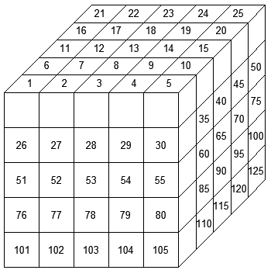

Figure 2. 5x5x5 Grid Model Used in Simulation

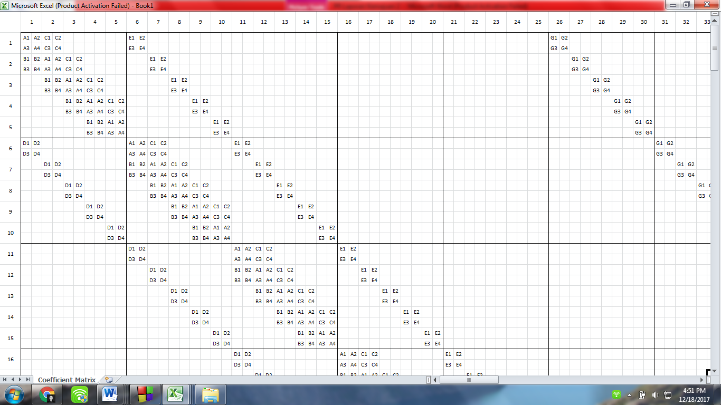

Figure 3. 5x5x5 Grid Model’s Coefficient Matrix Sample 1

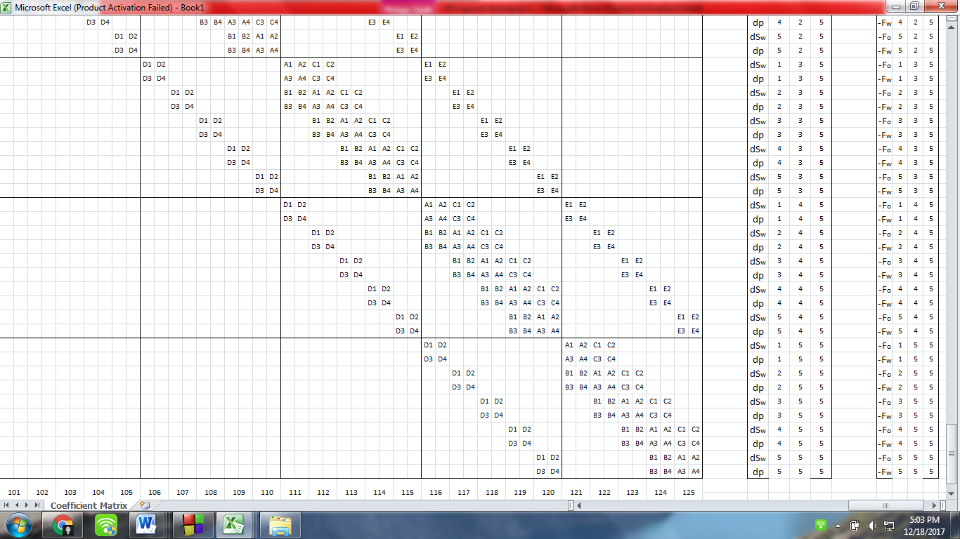

Figure 4. 5x5x5 Grid Model's Coefficient Matrix Sample 2

The coefficient matrix is visually generated to ease comprehending the way program to solve the equation system. The coefficient matrix will be solved using Newton-Raphson iteration method.

# Flow Chart

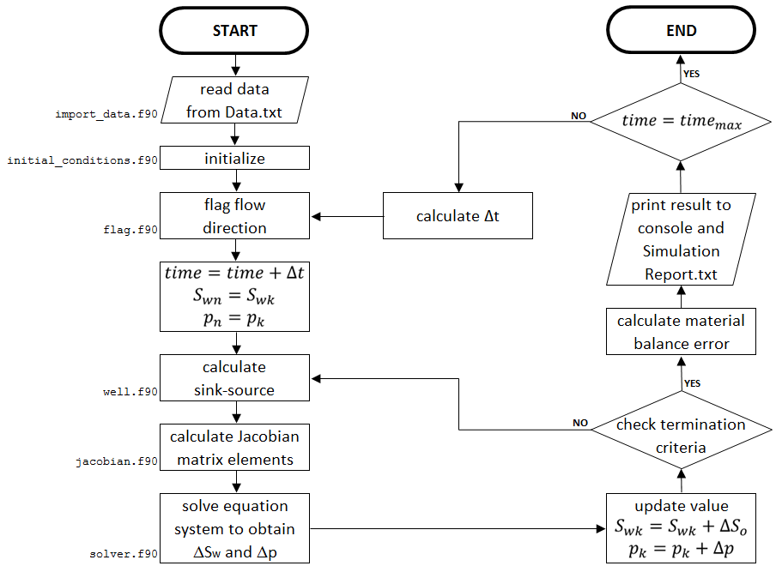

Figure 5. Fortran 90 Reservoir Simulator Flow Chart

# Waterflood Sensitivity Study

## Method of Sensitivity Study

Sensitivity study has been done in order to obtain optimum recovery factor. Fluid and rock physical properties, initial condition and well information are given. Reservoir geometry and well location are illustrated as below.

Reservoir with 4000 ft (i) ⨯ 4000 ft (j) area and 125 ft (k) thickness is modelled using 5⨯5⨯5 grid blocks (scale 1:125).

**PRODUCTION WELL**

**INJECTION WELL**

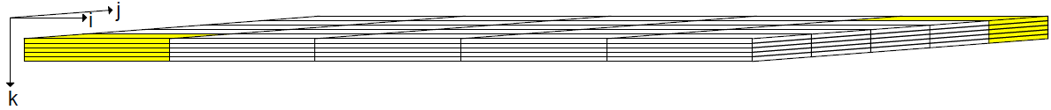

Figure 6. Reservoir Geometry and Well Location

Sensitivity study is run using fully implicit reservoir simulator that has been built by coding in Fortran 90. It’s initialized by validating simulator result from commercial simulator (CMG-IMEX). If the coded simulator gains a relatively valid result compared to commercial reservoir simulator, sensitivity study of injection rate and completion (perforation) location will be done to optimize recovery factor for 20 years operation.

There are constrains for this sensitivity study. Reservoir pressure is not allowed to exceed more than 4000 psia as optimization reason. And, reservoir pressure cannot be less than bubble point pressure, 808.8 psia.

## Validation Using Commercial Simulator

Validation between Fortran 90 Simulator and Commercial Simulator (CMG-IMEX) is done in order to use F90 Simulator for different scenario validly. Although there’s very slightly difference on the results, it can be neglected due to numerical error reason.

Figure 7. Result Comparison on Injection Rate vs Time

Figure 8. Result Comparison on Oil Production Rate vs Time

Figure 9. Result Comparison on Water Production Rate vs Time

Figure 10. Result Comparison on Water Cut vs Time

Figure 11. Result Comparison on Water-Oil Ratio vs Time

Figure 12. Result Comparison on Cummulative Water Injected vs Time

Figure 13. Result Comparison on Cummulative Oil Produced vs Time

Figure 14. Result Comparison on Cummulative Water Produced vs Time

Figure 15. Result Comparison on Injector Wellbore Pressure vs Time

Figure 16. Result Comparison on Producer Wellbore Pressure vs Time

## Recovery Factor Optimization

### Injection Rate Sensitivity

A single constant rate for both injection well and production well is applied for this simulation due to simplicity in obtaining the effect of injection rate toward recovery factor. Base case is run for 2000 days.

Table 1. Cases for Different Injection Rate

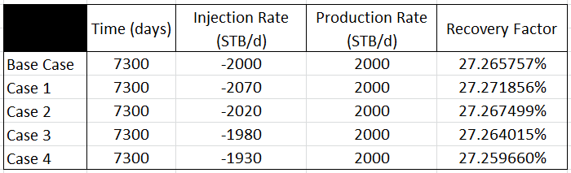

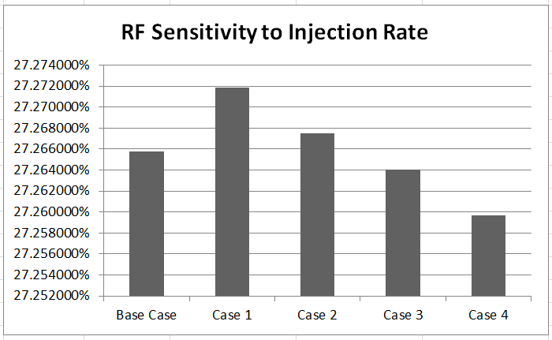

Figure 17. Recovery Factor Sensitivity to Injection Rate

We can see the result above that for injection rate below that of production, the higher injection rate is, the more recovery factor will be gained. And for injection rate above production rate, the higher injection rate is, the more recovery factor will be gained too. At least, these statements can be used to become a determining key to achieve optimum recovery factor.

### Completion Location Sensitivity

In base case scenario, injection well is perforated at 1,1,5 grid block coordinate (i,j,k) meanwhile production well is perforated at 5,5,5. This part of sensitivity study intends to know where should perforate each wells to achieve optimum recovery factor without changing the x,y coordinate (i,j). Base case is run for 2000 days.

Table 2. Cases for Different Well Perforation Depth

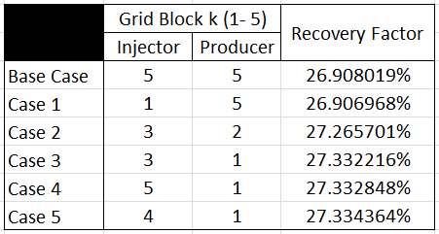

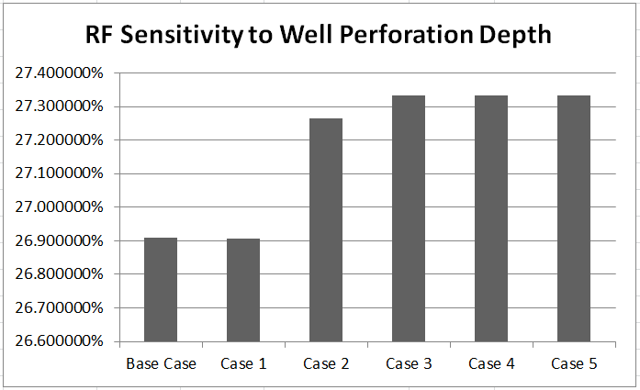

Figure 18. Recovery Factor Sensitivity to Well Perforation Depth

The result above implies that injection well which has shallower perforation than the perforation at production well will gain less recovery factor than the deeper one. But the result shows that we have to choose the perforation depth carefully because it doesn't produce a directly proportional increase in recovery factor when the more difference of the well perforation depth is simulated.

### Recommended Scenario

A scenario is recommended when maximum recovery factor can be achieved by adjusting injection rate and well perforation depth according to determining key we’ve learnt in the previous sensitivity studies.

Theoretically in this oil-water reservoir system simulation, the maximum recovery factor is around 80%. Because based on Data.txt, the value Swirr = 10% and the Sor = 90%. So, by simple subtraction 90% - 10%, the recovery factor would be around 80%.

But in this simulation, **student can achieve 75% recovery factor**. It can’t reach 80% probably due to numerical error during simulation is run. To achieve 75% recovery factor, writer used different injection & production rate from the ones in the sensitivity study through try and error but it still complies the determining key we’ve learnt. And, student used exactly same perforation depth in Case 5 because it produces the highest recovery factor in the sensitivity study and it still complies the determining key we’ve learnt. The chosen injection rate, production rate and well perforation depth is shown in Table 3.

Table 3. Recommended Case on Recovery Factor Optimization

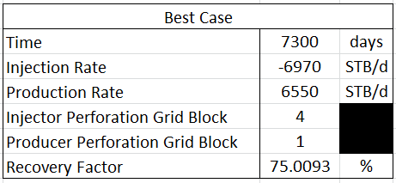

# Additional Notes

## Upstream Weighting

Scheme of upstream weighting is used to determine average relative permeability. Average relative permeability will use the value of relative permeability at upstream grid block. Potential difference is used to determine which grid block is the upstream. Piezometric pressure is assumed to represent potential, so

$${k_{r}}_{n±\frac{1}{2}}=\left\{\begin{aligned}{k_{r}}_{n}, &Φ_{n±1}<Φ_{n} \\ {k_{r}}_{n±1}, &Φ_{n±1}>Φ_{n}\end{aligned}\right.$$

See that the derivation of relative permeability to its neighbor will equal zero if the upstream grid block is not the neighbor grid block because average relative permeability is only the function of relative permeability at grid block itself, not neighbor.

$$\frac{d{k_{r}}_{n±\frac{1}{2}}}{d{S_{w}}_{n±1}}=\left\{\begin{aligned}0, &Φ_{n±1}<Φ_{n} \\ {\left.\frac{dk_{r}}{dS_{w}}\right|}_{n±1}, &Φ_{n±1}>Φ_{n}\end{aligned}\right.$$

## Fluid Physical Properties at Average Pressure

Fluid physical properties at average pressure can be obtained using chain rule. There are 3 variables that we need to concern about. These are $μ$, $B$ and $γ$. For example: viscosity, the derivative to its neighbor pressure is

$$\frac{dμ_{n±\frac{1}{2}}}{dp_{n±1}}=\frac{dμ_{n±\frac{1}{2}}}{dp_{n±\frac{1}{2}}}\frac{dp_{n±\frac{1}{2}}}{dp_{n±1}}$$

Because

$$p_{n±\frac{1}{2}}=\frac{p_{n}+p_{n±1}}{2}→\frac{dp_{n±\frac{1}{2}}}{dp_{n±1}}=\frac{1}{2}$$

Then

$$\frac{dμ_{n±\frac{1}{2}}}{dp_{n±1}}=\frac{1}{2}{\left.\frac{dμ}{dp}\right|}_{n±\frac{1}{2}}$$

## Partial Derivatives of Transmissibility to Neighbor Pressure and Water Saturation

$$\frac{dT}{dp_{n±1}}=-\frac{1}{2}λ_{n±\frac{1}{2}}PGEO{\left[\frac{dμ}{dp}+\frac{dB}{dp}\right]}_{n±\frac{1}{2}}$$

$$\frac{dT}{d{S_{w}}_{n±1}}=\frac{PGEO}{{\left(μB\right)}_{n±\frac{1}{2}}}\frac{d{k_{r}}_{n±\frac{1}{2}}}{d{S_{w}}_{n±1}}$$

## Bivariate Newton-Raphson

If we notice a function that is 2-function bivariate, then

$$f\left(x+∆x,y+∆y\right)=f\left(x,y\right)+∆x\frac{∂f}{∂x}+∆y\frac{∂f}{∂y}$$

$$g\left(x+∆x,y+∆y\right)=g\left(x,y\right)+∆x\frac{∂g}{∂x}+∆y\frac{∂g}{∂y}$$

To obtain a new guess, then

$$f\left(x+∆x,y+∆y\right)=g\left(x+∆x,y+∆y\right)=0$$

$$\left[\begin{matrix}f_{x} & f_{y} \\ g_{x} & g_{y}\end{matrix}\right]\left[\begin{aligned}∆x \\ ∆y\end{aligned}\right]=-\left[\begin{aligned}f\left(x,y\right) \\ g\left(x,y\right)\end{aligned}\right]$$

Thus

$$\left[\begin{aligned}∆x \\ ∆y\end{aligned}\right]=-{\left[\begin{matrix}f_{x} & f_{y} \\ g_{x} & g_{y}\end{matrix}\right]}^{-1}\left[\begin{aligned}f\left(x,y\right) \\ g\left(x,y\right)\end{aligned}\right]$$

$$∆X=-\frac{F\left(X\right)}{F^{'}\left(X\right)}$$

Where

$$X=\left[\begin{aligned}∆x \\ ∆y\end{aligned}\right] ;F=\left[\begin{aligned}f\left(x,y\right) \\ g\left(x,y\right)\end{aligned}\right]$$

If we expand that calculation

$$\left[\begin{aligned}∆x \\ ∆y\end{aligned}\right]=-\frac{\left[\begin{matrix}g_{y} & -f_{y} \\ -g_{x} & f_{x}\end{matrix}\right]\left[\begin{aligned}f\left(x,y\right) \\ g\left(x,y\right)\end{aligned}\right]}{\left|\begin{matrix}f_{x} & f_{y} \\ g_{x} & g_{y}\end{matrix}\right|}=\frac{1}{\left| J \right|}\left[\begin{aligned}g\left(x,y\right)f_{y}-f\left(x,y\right)g_{y} \\ f\left(x,y\right)g_{x}-g\left(x,y\right)f_{x}\end{aligned}\right]$$

Then

$$∆x=\frac{g\left(x,y\right)f_{y}-f\left(x,y\right)g_{y}}{\left| J \right|} dan ∆y=\frac{f\left(x,y\right)g_{x}-g\left(x,y\right)f_{x}}{\left| J \right|}$$

Where

$$J=Matriks Jacobian=\left[\begin{matrix}f_{x} & f_{y} \\ g_{x} & g_{y}\end{matrix}\right]$$

$$\left|J \right|=\left|\begin{matrix}f_{x} & f_{y} \\ g_{x} & g_{y}\end{matrix}\right|=f_{x}g_{y}-f_{y}g_{x}$$

## Easy Way to Calculate Flux Term Derivate at Block

Recall

$${F_{i}}_{flux}=T_{i+\frac{1}{2}}\left(p_{i+1}-p_{i}\right)+T_{i-\frac{1}{2}}\left(p_{i-1}-p_{i}\right)$$

By shifting it

$$F_{i-1}=T_{i-\frac{1}{2}}\left(p_{i}-p_{i-1}\right)+T_{i-\frac{3}{2}}\left(p_{i-2}-p_{i-1}\right)$$

$$F_{i+1}=T_{i+\frac{3}{2}}\left(p_{i+2}-p_{i+1}\right)+T_{i+\frac{1}{2}}\left(p_{i}-p_{i+1}\right)$$

Here’s the miracle

$$\frac{∂F_{i}}{∂p_{i}}=-\left(\frac{∂F_{i-1}}{∂p_{i}}+\frac{∂F_{i+1}}{∂p_{i}}\right)$$

It works for partial derivative towards saturation too. Hence, we can simply calculate the **flux term derivative** as

$${A_{i,j,k}}_{flux}=-\left(B_{i-1,j,k}+C_{i+1,j,k}+D_{i,j+1,k}+E_{i,j-1,k}+F_{i,j,k+1}+G_{i,j,k-1}\right)$$

To include sink-source and accumulation term, then it becomes

$$A_{i,j,k}=-\left(B_{i-1,j,k}+C_{i+1,j,k}+D_{i,j+1,k}+E_{i,j-1,k}+F_{i,j,k+1}+G_{i,j,k-1}\right)-acc_{i,j,k}-ss_{i,j,k}$$